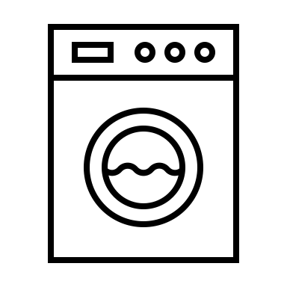

Zero waste cleaning

# Zero waste cleaning

**Zero-waste cleaning is a practical and eco-friendly way to maintain a clean home while reducing environmental impact. Conventional cleaning products often come in single-use plastic packaging and contain harsh chemicals that harm both the environment and your health. Switching to zero-waste alternatives begins with simplifying your cleaning supplies. Many household tasks can be accomplished with a few versatile, natural ingredients like vinegar, baking soda, castile soap, and lemon juice. For instance, a mix of vinegar and water works well as a glass cleaner, while baking soda can scrub sinks and tubs. These ingredients are safe, effective, and inexpensive, making them a perfect foundation for a zero-waste cleaning routine.**

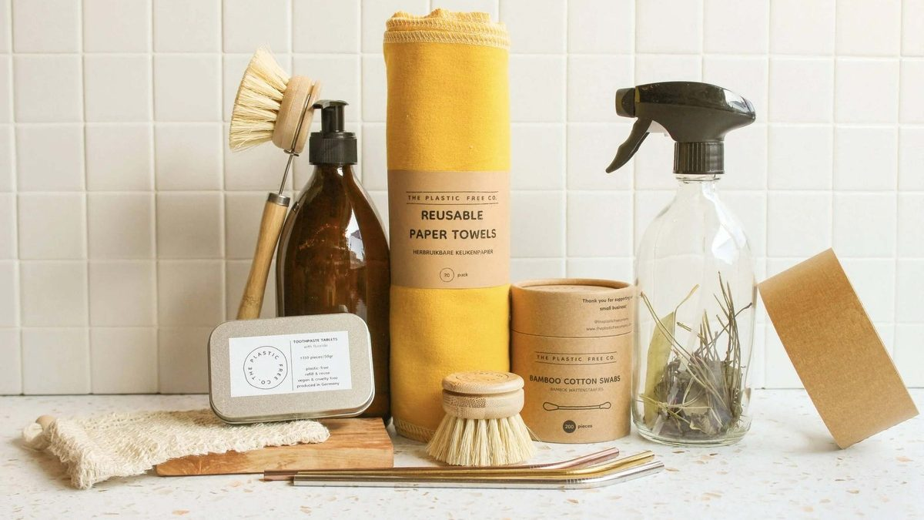**Investing in reusable cleaning tools is another essential step. Replace single-use paper towels with washable cloths or old cut-up T-shirts. Swap disposable sponges and pads for compostable alternatives made from natural materials like loofah or cellulose. For mopping, consider microfiber pads that can be washed and reused instead of significantly reduce waste while maintaining a clean and organized home. Additionally, look for eco-friendly brushes with wooden handles and natural bristles, which are biodegradable and free from plastic.**

**Many zero-waste cleaning products are also available in refillable formats or bulk quantities, which eliminate unnecessary packaging. Some brands offer concentrated cleaning solutions that can be diluted at home, reducing the need for multiple plastic bottles. You can also make your own multi-purpose cleaners using essential oils for fragrance and antibacterial properties. Tea tree oil, lavender, and eucalyptus are excellent choices for creating all-natural, pleasant-smelling cleaning products. Refilling containers and making your own solutions not only reduce waste but also allow you to customize products to your specific needs.**

**Finally, zero-waste cleaning encourages a mindset shift toward sustainability and minimalism. Rather than accumulating specialized cleaners for each surface or material, embrace the idea that a few simple, multi-purpose solutions can handle most household tasks. This approach not only cuts down on clutter but also promotes mindful consumption and reduces your environmental footprint. By adopting a zero-waste cleaning routine, you create a healthier home and contribute to a more sustainable future for the planet.**